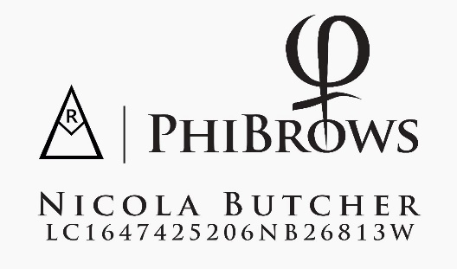  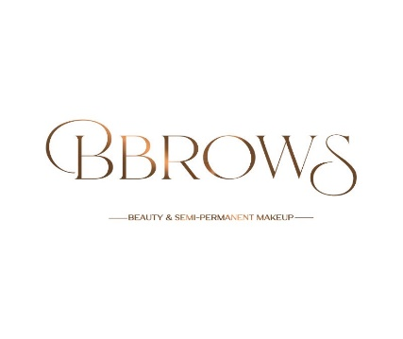

**CONSENT FORM FOR SEMI-PERMANENT COSMETICS PAGE 1 OF 4**

|  |  |
| --- | --- |
| **Bbrows Studio** | **Name** |
| 49 Halfgayne Road | **Address** |
| Maghera |  |
| Co Derry |  |
| BT46 5NL |  |
| **Treatment Area & amount Paid** | **Date of Birth** |
|  | **email address** |
|  | **Mobile Number** |
| **FIRST TREATMENT**   * **Tools used** * **Pigment used** | |
| **TOP UP**  **DATE :**   * **Retention %** * **Pigment used** * **Tools used** | |

***This form is designed to give you a full understanding of pigmentation treatment, it is designed to inform you and outline all risks associated with Semi Permanent Makeup.***

*BBROWS STUDIO* is obligated to perform treatment in strict compliance with all hygiene and health protection measures, compliant with legal legislation, council regulations and insurance.

All question must be answered, failure to do so may result in the treatment not being carried out. All information is confidential, and it shall also be handled in that way *BBROWS STUDIO* assumes no liability in case of giving false information.

OFFICE NOTES

|  |
| --- |
|  |

1. **HEALTH CONDITION QUESTIONNAIRE PAGE 2 OF 4**

|  |  |  |
| --- | --- | --- |
| Hemophilia (blood does not clot easily) | YES | NO |
| Diabetes | YES | NO |
| Hepatitis A, B, C, D, E, F | YES | NO |
| HIV + | YES | NO |
| Skin diseases | YES | NO |
| Eczema/dermatitis | YES | NO |
| Autoimmune diseases | YES | NO |
| Are you prone to herpes/cold sores, if yes how long from your last breakout? | YES | NO |
| Have you had an infectious diseases high fever in the last 7 days | YES | NO |
| Epilepsy | YES | NO |
| Cardiovascular problems | YES | NO |
| Are you taking medication for blood thinners | YES | NO |
| Are you pregnant/breast feeding | YES | NO |
| Have you underwent cancer treatment in the last 12 months, If yes you will need a letter from your GP for insurance purposes | YES | NO |
| Do you have a pacemaker | YES | NO |
| Do you have problems with healing of wounds/keloid scars | YES | NO |
| Have you taken aspirin/ibuprofen/alcohol in the last 48 hours | YES | NO |
| Do you have any moles/scaring on the area to be treated | YES | NO |
| Do you have any Allergies, if yes Please list: | YES | NO |
| Do you have oily skin | YES | NO |
| Have you had your brows/lips previously done, If yes when was you last semi-permanent treatment? | YES | NO |
| Have you used Retinol, glyolic, AHA’s, Acids & skin peels,  In the last 4 weeks | YES | NO |
| Have you had Botox/fillers in the last 4 weeks | YES | NO |
| Have you had Laser/light therapy in the last 4 weeks | YES | NO |
| Have you Wax/pluck/laminate eyebrows in the last 48h | YES | NO |
| Have you taken Fish oil/natural blood thinners in the last week | YES | NO |
| Have you taken caffeine/alcohol/spicy foods in the last 24h | YES | NO |
| Are you currently taking a course of antibiotics | YES | NO |
| Please list below any medication that you take daily: | | |

1. **RISKS, PATCH TEST & SOCIAL MEDIA PAGE 3 OF 4**

|  |  |  |
| --- | --- | --- |
| I understand the treated area may be at risk of bleeding, swelling and or allergic reaction. | YES | NO |
| I understand that correction/cover up work must be faded/removed and may require more touch up’s and that my results will depend on; colour, depth, type, placement & saturation of old pigment. | YES | NO |
| I understand that semi-permanent makeup is considered a tattoo, it may fade over time but never completely leave the skin. | YES | NO |
| I understand that every effort will be made to avoid asymmetry, but our faces are not symmetrical and droop over time, adjustments may be needed in the future | YES | NO |
| I understand that implanted pigment colour can change, orange, pink, grey & fade over time due to circumstances beyond your control. | YES | NO |
| I understand that a touch up appointment is required in 4-8 weeks and that oily/combination skin may require more touch ups. | YES | NO |
| I understand that the pigment may heal uneven due to poor healing, aftercare, infection or bleeding & may other causes, your touch up will likely correct any uneven appearances. | YES | NO |
| I understand that I will need to maintain the colour/shape with future treatments and that regular brow tinting & waxing is advised. | YES | NO |
| I understand that colour refreshes are required between 1-3y no sooner than 12m and that this will very for each client some lasting longer, and that brows must be faded to a workable level to avoid build-up/saturation off pigment. | YES | NO |
| I understand that tattoo can only be removed with laser/saline it could take may session and may scar. | YES | NO |
| I agree that in the case were natural hair must be taken away to achieve symmetry. | YES | NO |
| I confirm that I have been given enough information to make an informed decision on the treatment. | YES | NO |
| I confirm that the pre & after care have been explained to me which I will follow to the best of my ability if you have any questions, please message | YES | NO |
| I confirm that I have been given the opportunity to ask questions regarding procedure, risks & hazards. | YES | NO |
| I confirm that I have been given a patch test & had NO reaction and that this does still not prevent a future reaction | YES | NO |
| Our insurance company requires “before & after” photos/videos to be taken & kept on file. We would like your consent to use these for advertising eg; portfolios, online & printed adds. | YES | NO |

**6. DISCLAIMER AND CONSENT PAGE 4 0F 4**

|  |  |
| --- | --- |
| On the day of the appointment, the area must be in good/healthy condition and pre-care must be followed, *BBROWS STUDIO* Reserves the right to rescheduled/cancelled your appointment | YES NO |
| Healed results will differ for each client, pigment retention will depend on your immune system, skin type, metabolism, medication, skincare, pre/after care, and lifestyle, therefore your results are beyond our control *BBROWS STUDIO* excepts no liability thus providing a warranty of guarantee is not possible | YES NO |
| I understand that a non-refundable deposit is required to secure booking and addition touch up appointments are at an extra cost. | YES NO |
| I confirm that I have read and fully understand this form and that I have completed honestly, I accept all the risks and do not hold *BBROWS STUDIO* responsible for any unhappy result. | YES NO |
| **PRINT NAME:** | **DATE** |
| **CLIENT SIGINTURE** |  |
| **VALID WITH OUT A SIGINTURE OR STAMP** |  |